**Questionnaire Application Analysis**

This application is used to handle the questionnaire control for Openethics. Once an ethics applicant creates an ethics application, he/she will be directed to questionnaire forms to be filled. From the admin point of view, there is a requirement to modify the arrangement of questions easily. Related to this requirement, five base models will be created for this application.

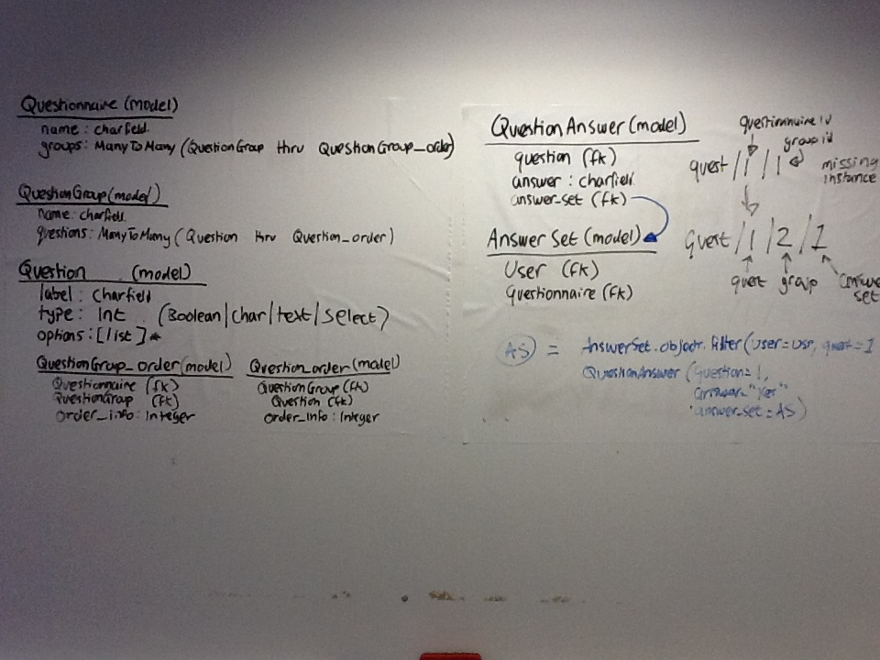

1. Questionnaire model.

The idea of creating this model is the need to facilitate the arrangement possibilities of many types of questionnaire. The arrangement will be done by changing the appearance sequence of group of question. The group of question itself is another model of Questionnaire application. The class design of this model is:

|  |
| --- |
| Questionnaire (model) |
| name : Charfield  QuestionGroup (manyToMany) |

1. QuestionGroup model.

This model is responsible to handle questions. Questions are grouped based on particular rule. The idea is, when a certain group is called by any method, it will show all questions relating to the group on the form or page.

|  |
| --- |
| QuestionGroup (model) |
| name : Charfield  Question (manyToMany) |

1. Question model.

This model is responsible as question bank. All possible questions will be kept by this model. This model should be flexible for assigning particular type of question. The type of question will determine how the applicant will answer the question, whether clicking a choice list or inputting a statement.

|  |
| --- |
| Question (model) |
| label : Charfield  type : Integer [Boolean, Char, Text, Select]  option : [list] |

1. QuestionGroup_order model.

This model functioned as many to many relational tables between Questionnaire model and QuestionGroup model. As a through class, it holds the relationship of Questionnaire and QuestionGroup Object with a variable (order_info) that is facilitated with an ordering control of showing its member sequentially.

|  |
| --- |
| QuestionGroup_order (model) |
| Questionnaire (Fk)  QuestionGroup (Fk)  order_info : Integer |

1. Question_order model.

This model is functioned as many to many relational tables between QuestionGroup model and Question model. As a through class, it holds the relationship of QuestionGroup and Question Object with a variable (order_info) that is facilitated with an ordering control of showing its member sequentially.

|  |
| --- |
| Question_order (model) |
| QuestionGroup (Fk)  Question (Fk)  order_info : Integer |

In addition, as a complement of these models, there is a need to make other models to represent the answer of questions. The answer models need to keep information about who is the applicant, what questionnaire is being answered, and for sure question-answer relation. Thus, there are 2 models planned related to the answer.

1. AnswerSet model.

This model is used to hold information about who the applicant is and what questionnaire is the user being answered or assigned to.

|  |
| --- |
| AnswerSet (model) |
| User (Fk)  Questionnaire (Fk) |

1. QuestionAnswer model.

This model is used to keep the relation between an answer and its related question. Note that it also holds the relationship to identify AnswerSet(User,Questionnaire), this hopefully can be used to identify if a user has answered specific Questions.

|  |
| --- |
| QuestionAnswer (model) |
| Question (Fk)  Answer : Charfield  AnswerSet (Fk) |